October 6th Lesson #1 Fighting Evil with Love

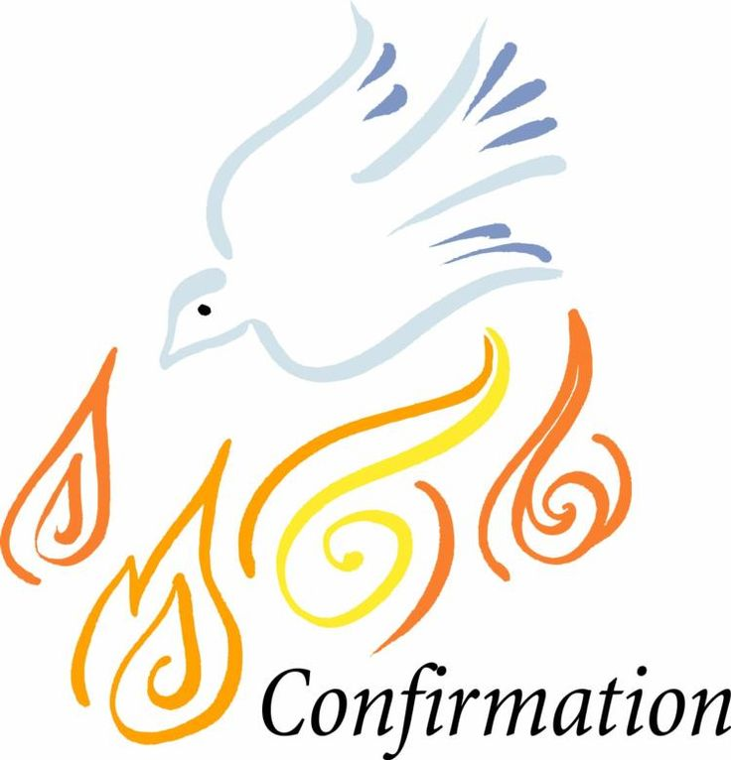

The Chosen – Season 1 Devotion #3 - Character

In this video Jesus teaches the children about how we should live in God’s kingdom, not as rebels but with love and forgiveness.

___Watch the Chosen Video

___Read the devotion out loud

___Talk about it

___Watch the Bible Project Video (write 2-3 take-a-ways on back)

___My thoughts on the Reflection Questions

___Using a Bible look up and write out the Bible verses

My thoughts on the Reflective Questions

#1

#2

#3

Matthew 5:43-45

Matthew 18:1-5

Matthew 19:13-14

Which of these Bible passages speak to you the most and why?

Parent Signature Confirmand signature date

October 13th Lesson #2 Saved by a Gift



The Chosen – Season 1 Devotion #4 God’s Grace & Favor

Jesus meets Peter and asks him to throw down his nets and then asks Peter and the other disciples to follow him to be fishers of men.

___Watch the Chosen Video

___Read the devotion out loud

___Talk about it

___Watch the Bible Project Video (write 2-3 take-a-ways on back)

___My thoughts on the Reflection Questions

___Using a Bible look up and write out the Bible verses

My thoughts on the Reflective Questions

#1

#2

#3

#4

Luke 5:1-11

Ephesians 2:4-8

Which of these Bible passages speak to you the most and why?

Parent Signature Confirmand signature date

October 20th Lesson #3 Divine Love Filled Full



The Chosen – Season 1 Devotion #5 Faith & Forgiven

Jesus heals the paralyzed man that is lowered down through the roof.

___Watch the Chosen Video

___Read the devotion out loud

___Talk about it

___Watch the Bible Project Video (write 2-3 take-a-ways on back)

___My thoughts on the Reflection Questions

___Using a Bible look up and write out the Bible verses

My thoughts on the Reflective Questions

#1

#2

#3

Mark 2:1-12

Romans 13:8-10

Which of these Bible passages speak to you the most and why?

Parent Signature Confirmand signature date

October 27th Lesson #4 The Journey is the Destination



The Chosen – Season 1 Devotion #6 Born again

Nicodemus, a Pharisee, secretly meets with Jesus and asks “What have you come here to show us?”

___Watch the Chosen Video

___Read the devotion out loud

___Talk about it

___Watch the Bible Project Video (write 2-3 take-a-ways on back)

___My thoughts on the Reflection Questions

___Using a Bible read the Bible verses and answer questions

My thoughts on the Reflective Questions

#1

#2

#3

Read John 3:1-17

How can you relate to the confusion Nicodemus has about being born again and why? If you were Nicodemus, would you drop everything and follow Jesus?

Parent Signature Confirmand signature date

November 10th Lesson #6 The Power of refusing to fight



The Chosen – Season 2 Devotion #1 Our role as a royal priest

When Jesus, James and John come across Samaritans – there is a confrontation – James and John react with the human condition of retribution. Instead, Jesus demonstrates the loving power of God

___Watch the Chosen Video

___Read the devotion out loud

___Talk about it

___Watch the Bible Project Video (write 2-3 take-a-ways on back)

___My thoughts on the Reflection Questions

___Using a Bible read the Bible verses and answer questions

My thoughts on the Reflective Questions

#1

#2

#3

Read Philippians 2:3-11

Jesus tells the disciples to do nothing____________________________

Rather in humility____________________________________________

Imagine having a confrontation with someone, what would it look like to respond with the loving power of God?

Luke 23:34 – Write out this bible verse and underline Jesus’ main point.

Parent Signature Confirmand signature date

November 3rd Lesson #5 Heaven Comes to Earth



The Chosen – Season 2 Devotion #5 Prayer

Jesus returns from being taken by the Roman soldiers. Jesus teaches the disciples that prayer is the first step to getting the mind and the heart right.

___Watch the Chosen Video

___Read the devotion out loud

___Talk about it

___Watch the Bible Project Video (write 2-3 take-a-ways on back)

___My thoughts on the Reflection Questions

___Using a Bible read the Bible verses and answer questions

My thoughts on the Reflective Questions

#1

#2

#3

Read Matthew 6:5-14 complete the verses.

Verse 5. When you pray do not be like the _______________________.

Verse 6. But when you pray___________________________________

__________________________________________________________.

9. Pray like this:

Parent Signature Confirmand signature date

November 17th Lesson #7 Living in right relationship



The Chosen – Season 3 Devotion #2 Justice-new kind of faith

Matthew, seeks forgiveness from his parents - atonement

___Watch the Chosen Video

___Read the devotion out loud

___Talk about it

___Watch the Bible Project Video (write 2-3 take-a-ways on back)

___My thoughts on the Reflection Questions

___Using a Bible look up and write out the Bible verses

My thoughts on the Reflective Questions

#1

#2

#3

Psalm 133:1-3

Matthew 5:23-26

What does Righteousness mean?

What does atonement mean?

Parent Signature Confirmand signature date

November 24th Lesson #8 Facing our own tests



The Chosen – Season 3 Devotion #6 Choosing to Trust God

Peter needs to face the painful challenge of trusting Jesus during the storms of life.

___Watch the Chosen Video

___Read the devotion out loud

___Talk about it

___Watch the Bible Project Video (write 2-3 take-a-ways on back)

___My thoughts on the Reflection Questions

___Using a Bible read the Bible verses and answer questions

My thoughts on the Reflective Questions

#1

#2

#3

#4

Matthew 14:22-36

What does Jesus say to the disciples, when he gets close to the boat.

Colossians 3:1-3

What does this verse say we should set our minds? What do you think that means?

Parent Signature Confirmand signature date